Mini Project 2

**Application mp1a.py:**

Aim: To create a Python script that models a priority queue of tasks given the following criteria:

**Mp2a:**

* Priority queue is a list of dictionaries. Priority level is specified as a range of integers (0...9, 9 is lowest priority)
* Key is a priority level identifier as string data .Value is a list of dictionaries task descriptions in insertion order of the tasks  during runtime with key => timestamp (date and time) and the value =>  task description
* method get() retrieves the head of the list based on highest priority, non-  empty list which is the first element in the dictionary at that level
* method put() appends a new dictionary element to the correct priority level  dictionary based on its priority level
* method list_all() prints a formatted representation of the entire PQ
* provide simulation data exhibiting all priority queue functionality from your  driver (top-level) code

**Mp2b:**

* Priority queue is a list of dictionaries
* Priority level is specified as a range of integers (0..9, 9 is lowest priority)
* Key is a priority level in string or int type
* Value is the list of Task objects which maintain attributes of id, timestamp and description

**Mp2c:**

Priority queue of tasks using tasks objects from mp2b.py, the stdlib priority queue

priority queue is an instance of PriorityQueue

* Priority level is specified as a range of integers (0..9, 9 is lowest priority)
* Key is a task name in string type
* Value is the priority level of the task

Project Description:

* The Project implements the priority queue with different formats
* In mp2a, the priority queue consists of a list of dictionaries with key as the priority level in the range of 0…9 with 0 having highest priority and value as the list of dictionaries with keys as the time-stamp when the object is being inserted and the value being the description of the task
* In mp2b, the priority queue consists of a list of dictionaries with key as the priority level and the value a list of objects of class Task. The class Task has attributes like Task ID, time-stamp and Description
* In mp2c, the priority queue is an object of the in-built class PriorityQueue and it imports the class Task from mp2b and uses its objects to put in the created queue.
* The format of the queue is a tuple of priority value and the task details like timestamp and description
* Methods like put(), get() and list_all() are included in all the three parts of mp2 in order to insert item into the queue , get item from the queue having highest priority and to display the contents from the queue

Project Insight:

* In order to implement the three parts of the program, have implemented the logic to take care of the various formats of the priority queue
* Used dict() , dict.fromkeys() in order to combine the key:value pair into a dictionary element
* Used getattr() method to get the details of the invoking object by specifying the name of the object and the attribute
* Used the in-built functions provided by the PriorityQueue class
* Performed various operations such as pop(), append() and sort() on the list which actually corresponds to the needed priority queue
* Made use of the datetime.datetime.now() in order to get the current system date and time

Expected Results:

* The program will display the list of items getting added to the queue, it will sort the queue depending on the priority level and it will display the current status of the queue
* The queue will pop the item out if the item’s priority is high

Screen Captures:

Code structure and Output Files:

*Mp2a:*

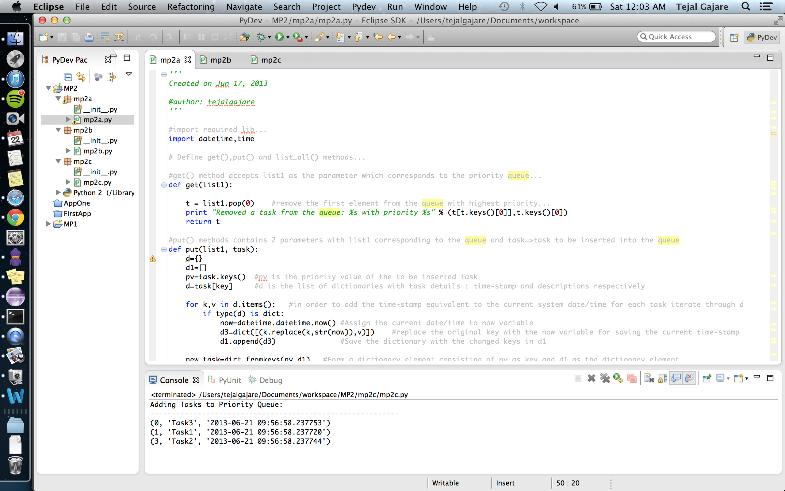

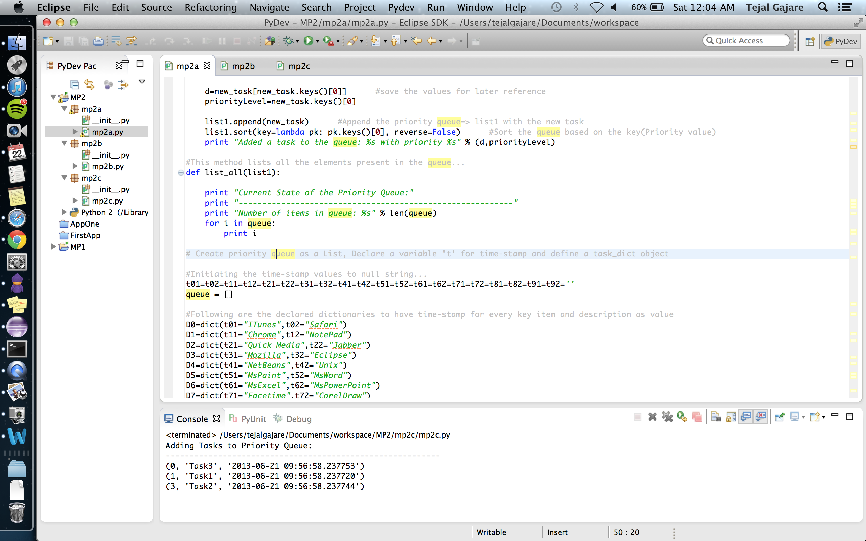

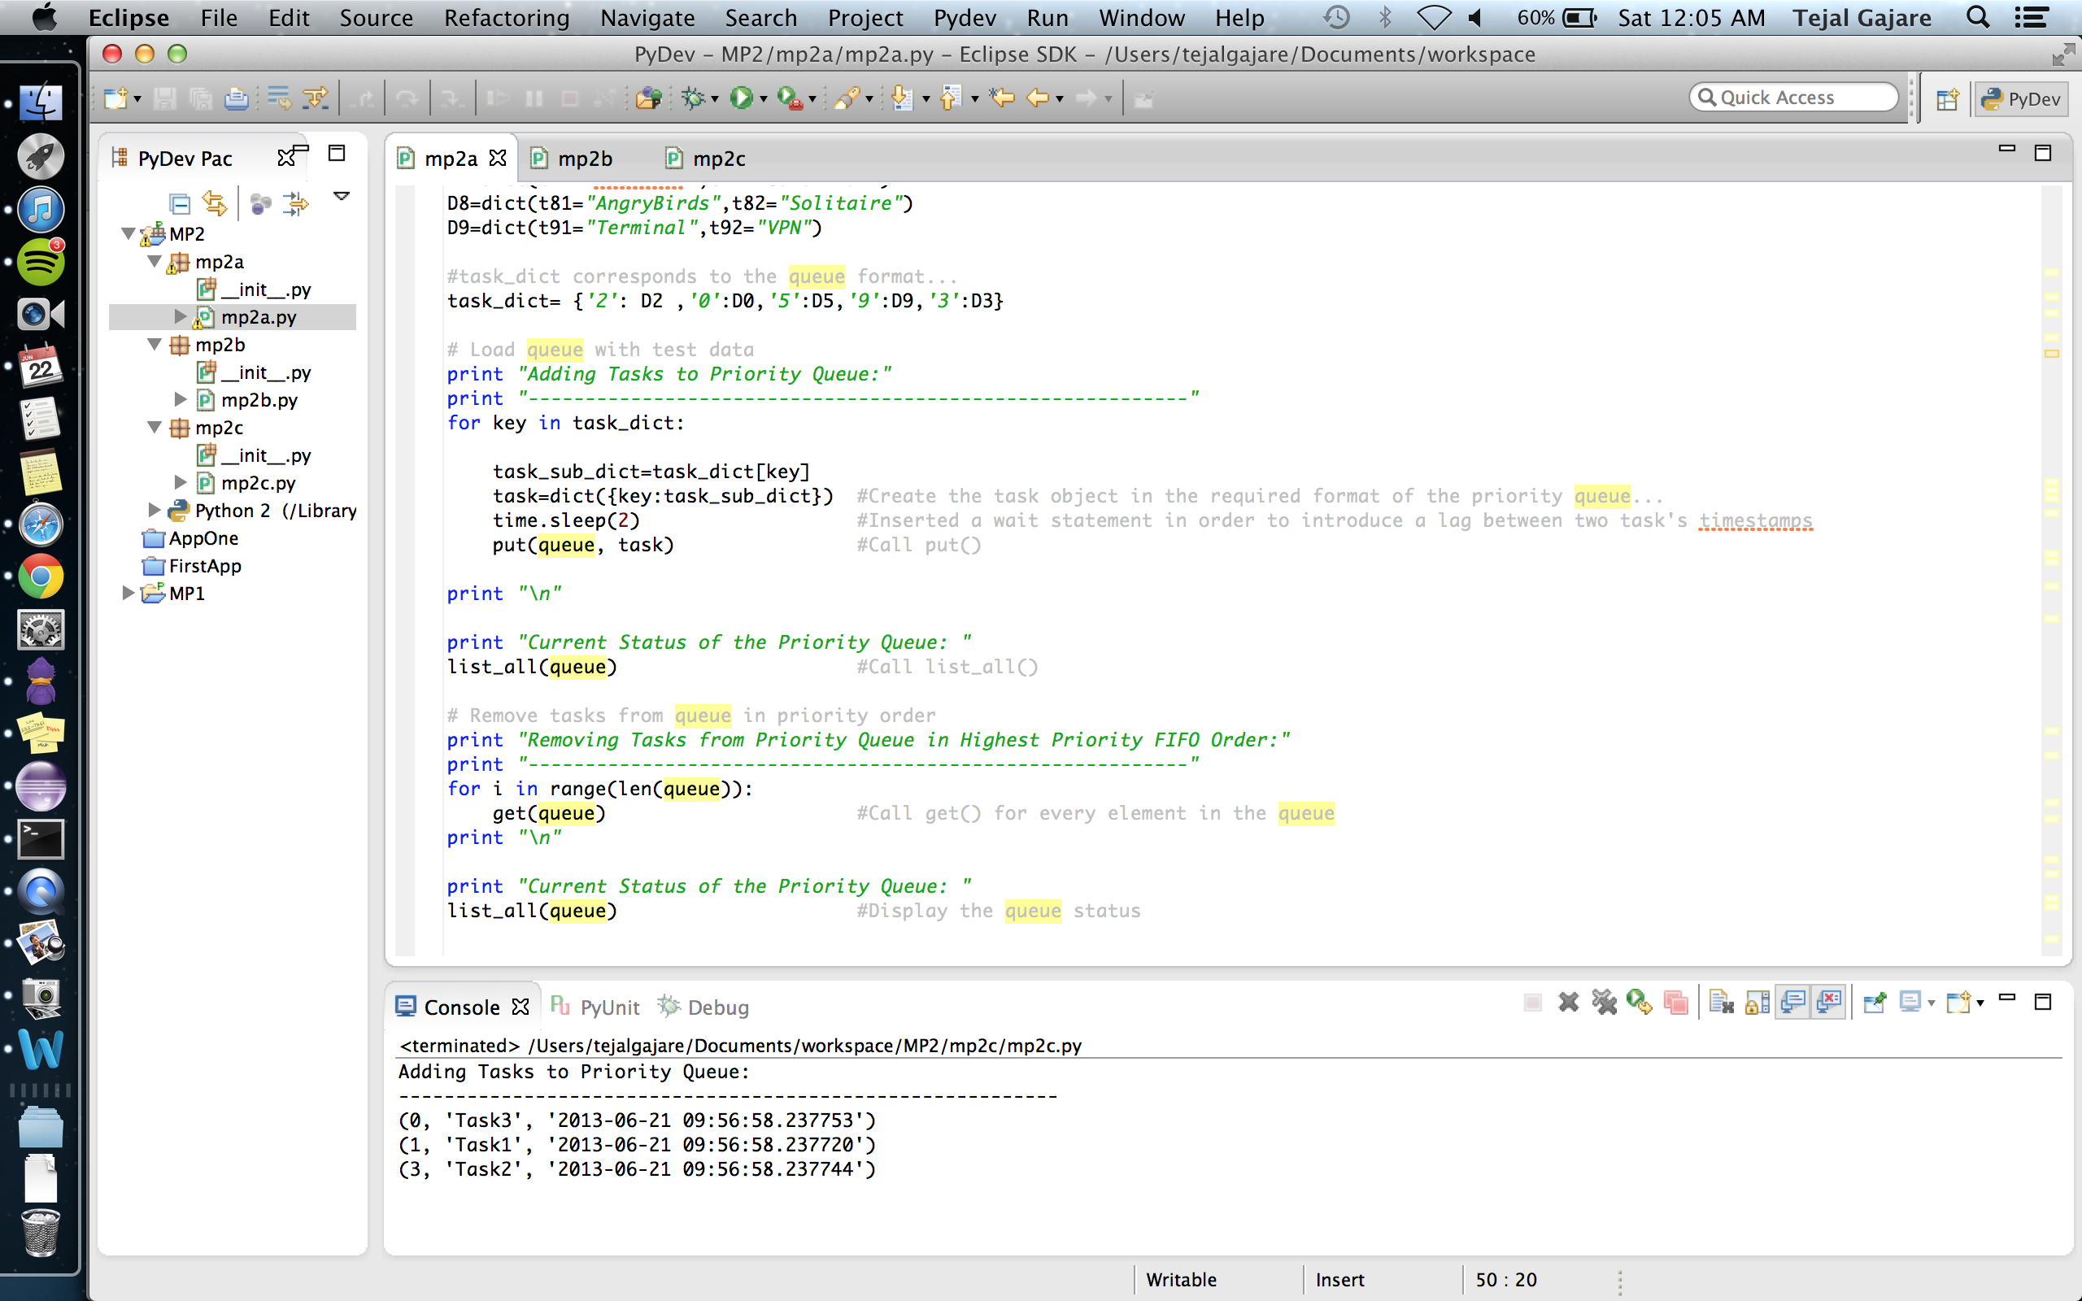

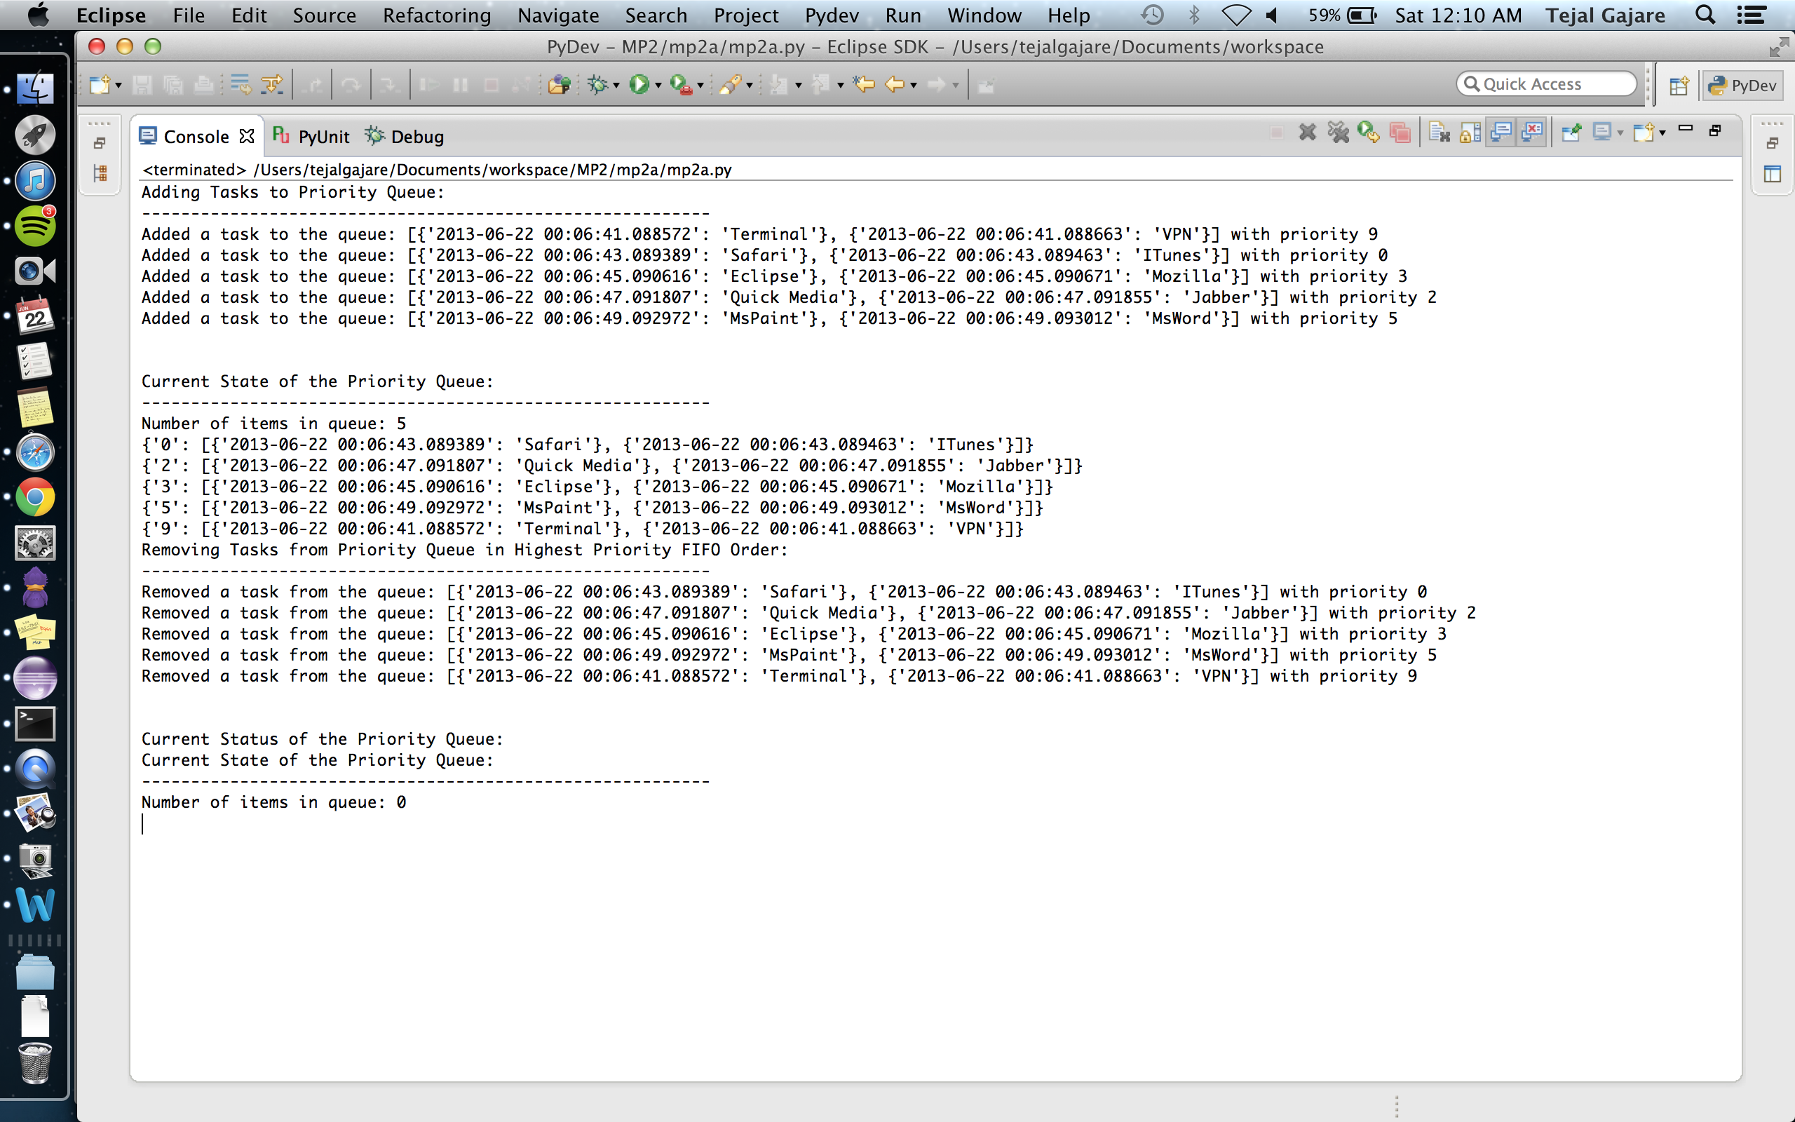

*Mp2b:*

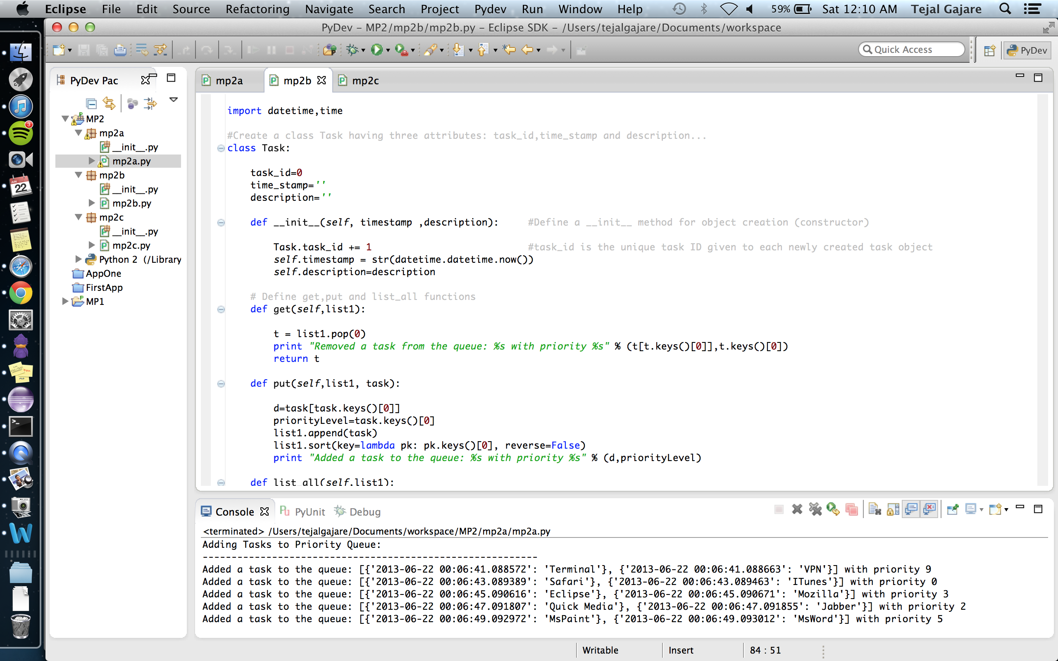

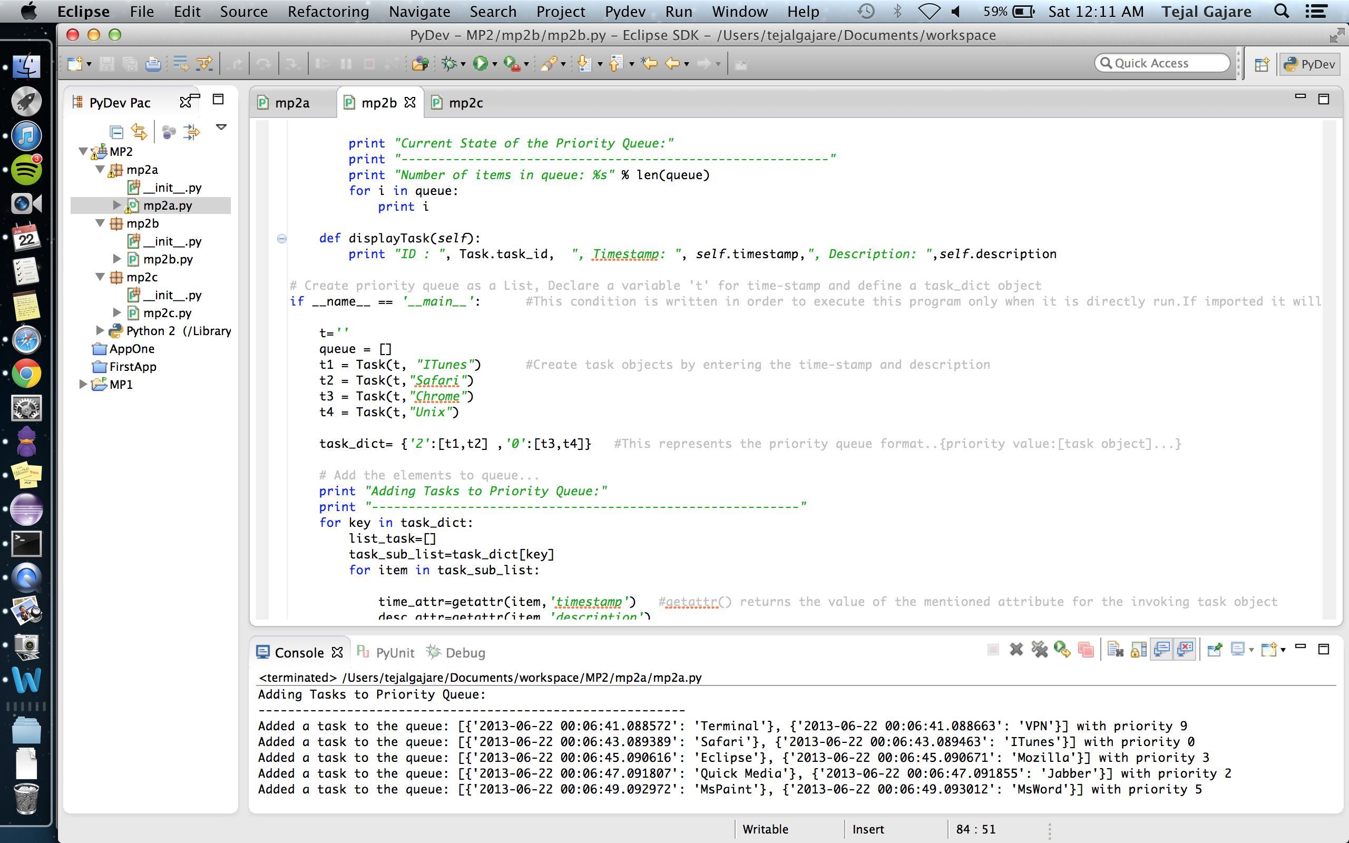

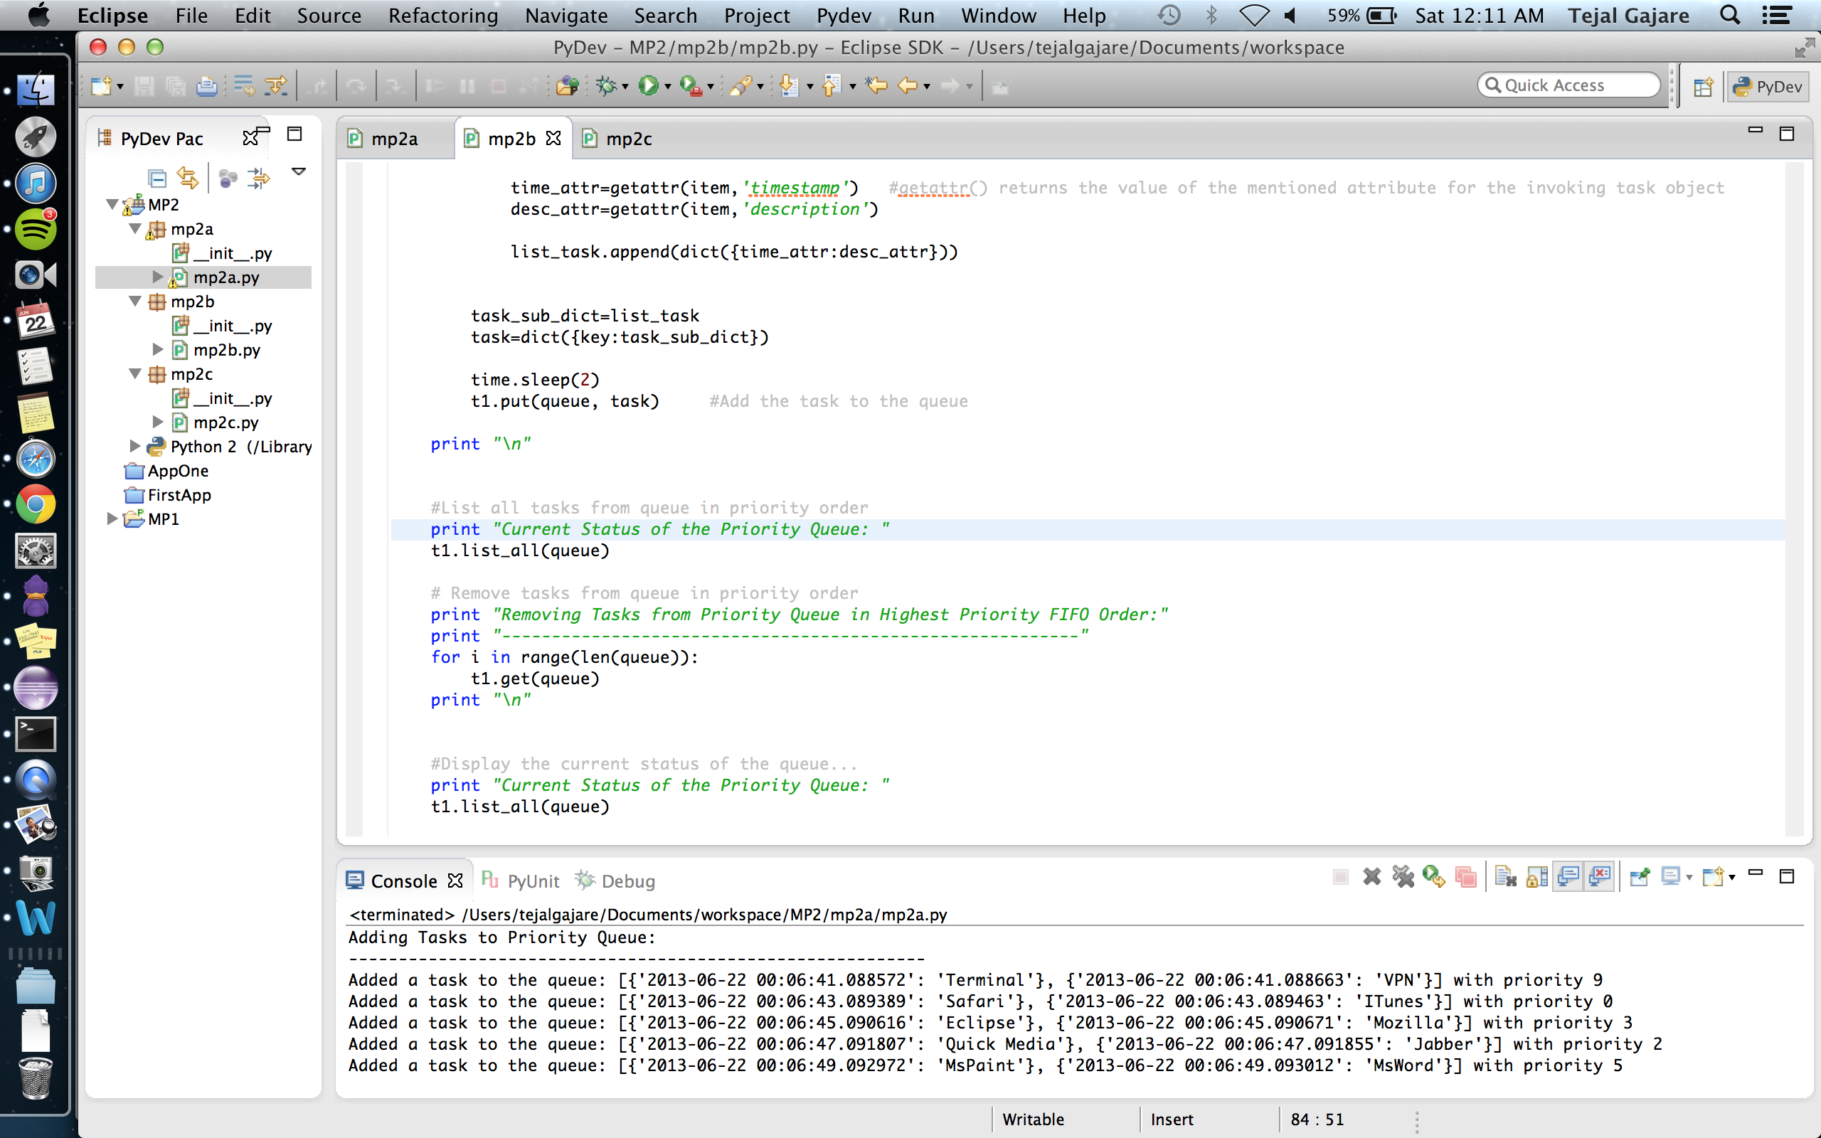

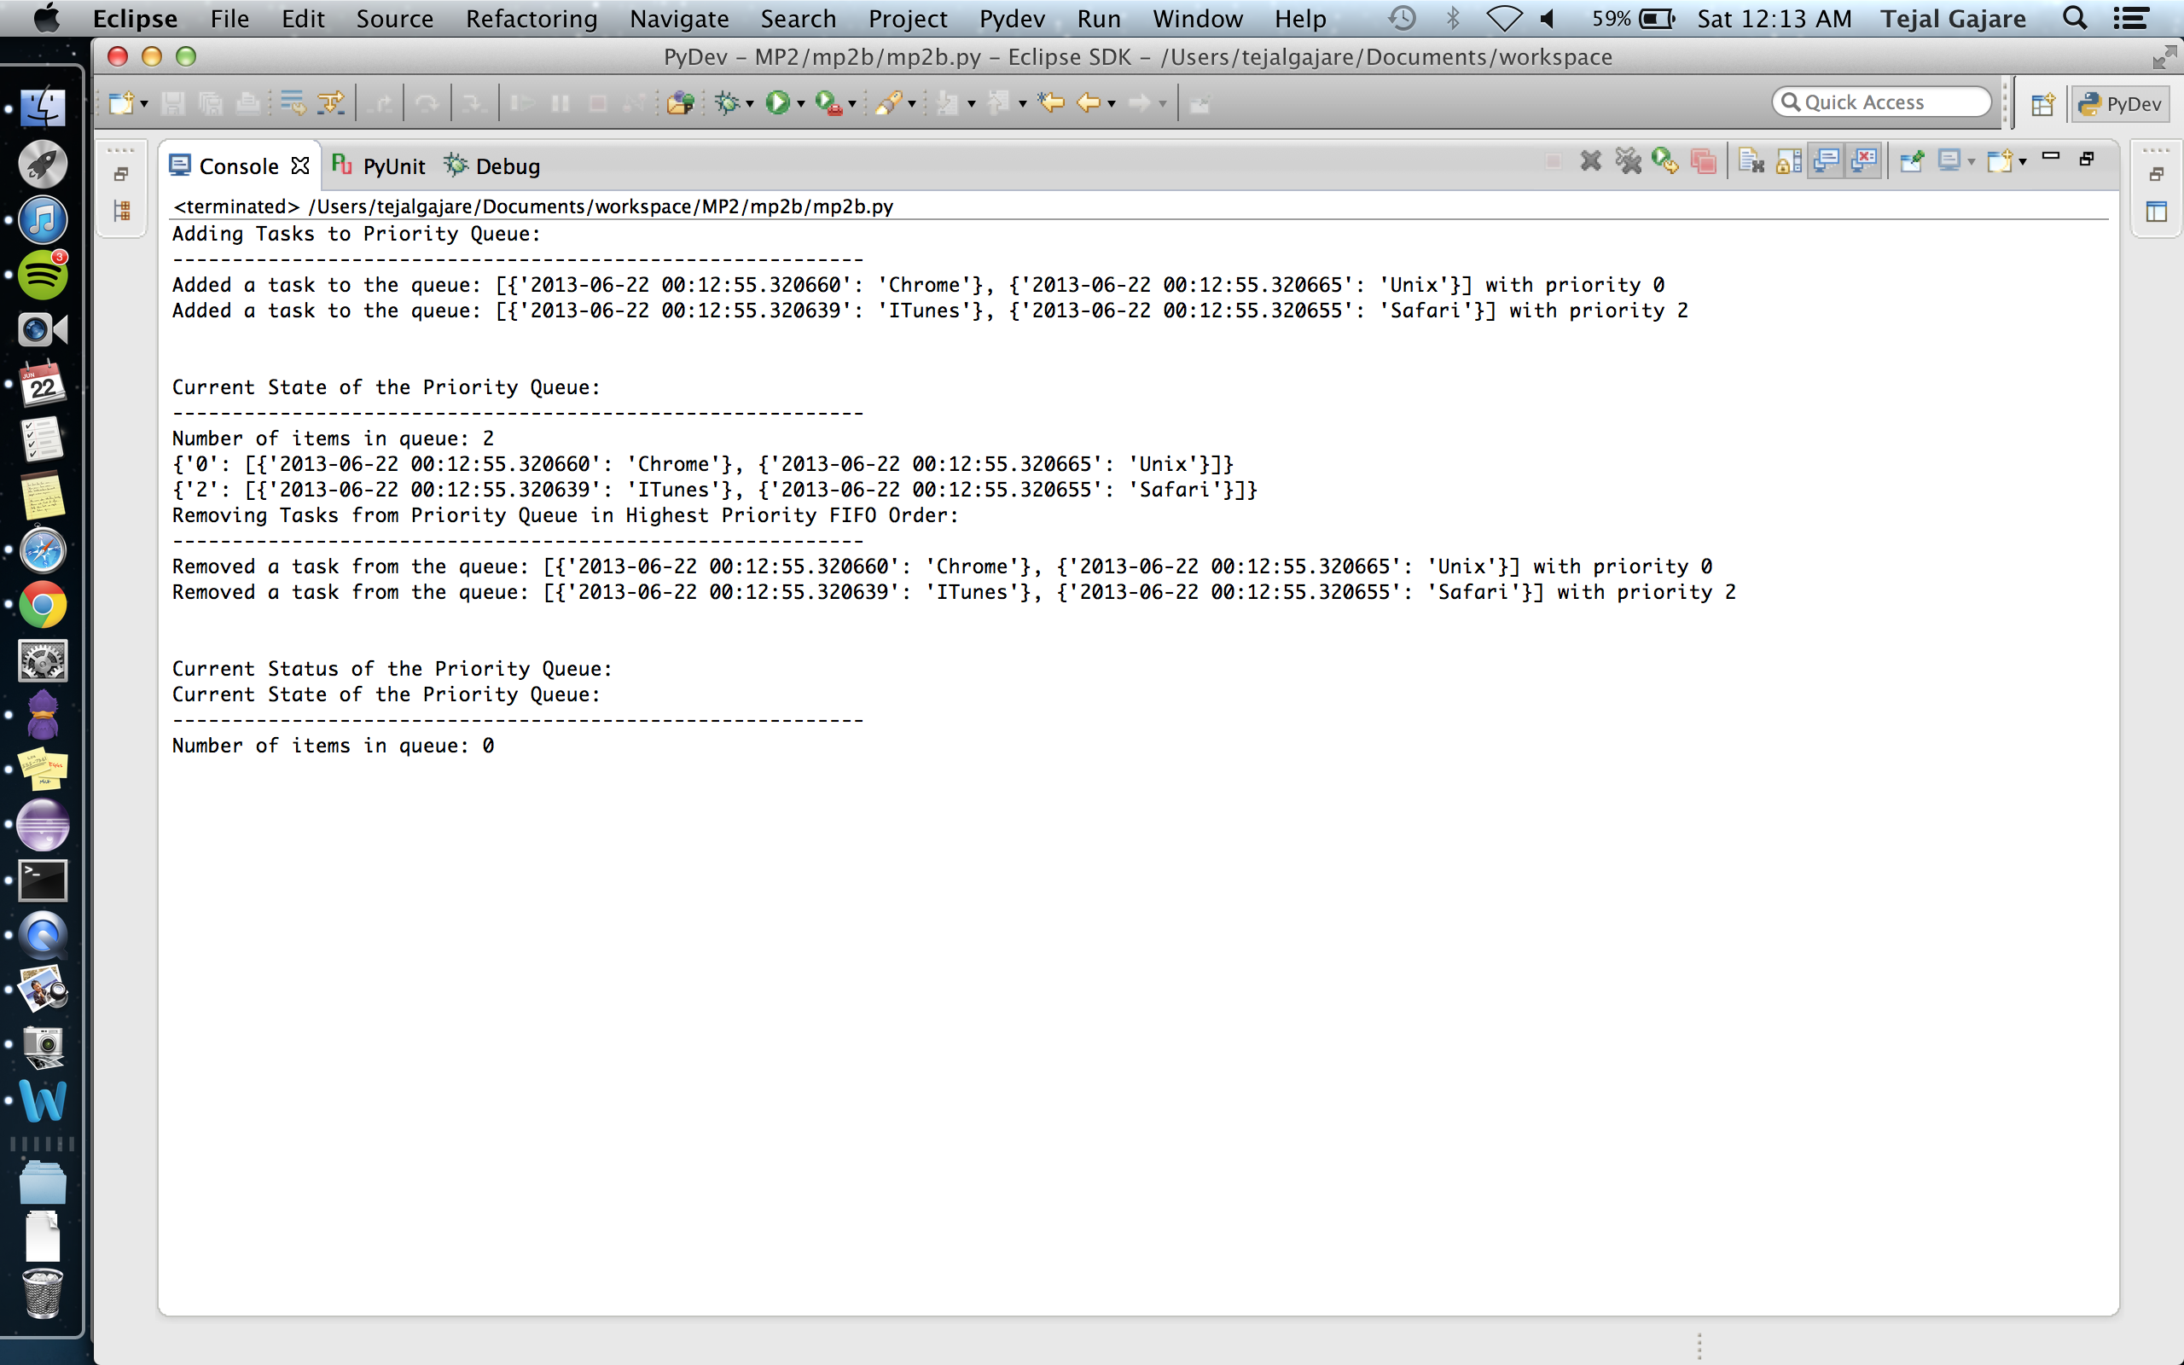

*Mp2c:*

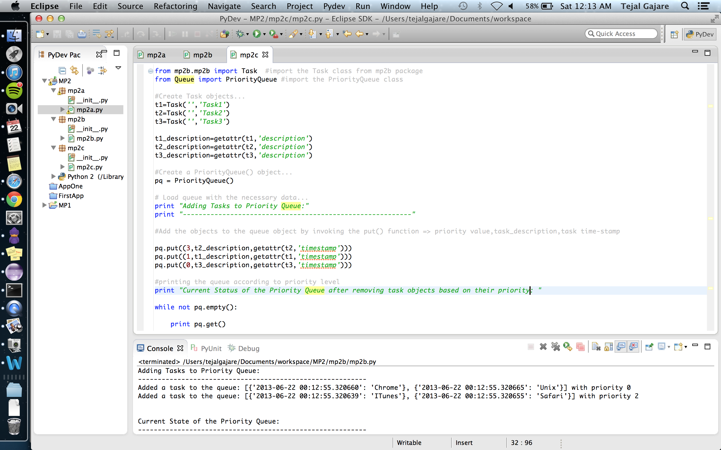

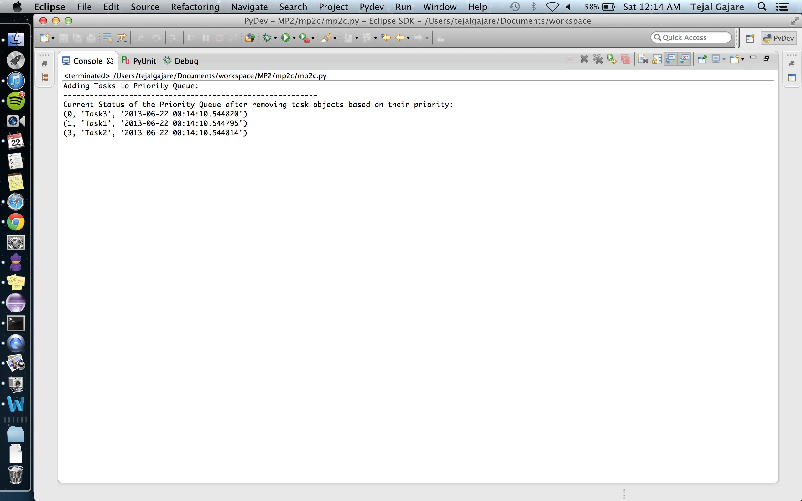

**Installation, Compile and Run-Time Requirements:**

* Python 2.7 / Python 3
* IDE: Eclipse Juno (Configure Eclipse to have PyDev)
* OS used: Mac OS 10.8.3